Change Request

|  |
| --- |
| **Change Request Brief** |
| Since LaaS is going into sunset, there’s requirement for Creating My Account for customer service, where customers can self-serve their request and able to view basic loan details along with option of paying outstanding and EMI using MyAccount. |

**Workflow:**

* **Option should be for both clix capital and Clix housing customers to login**
* Customer will land in MyAccount page and enter his Mobile number/E-Mail which will be OTP verified
  + Condition #1
    - In case entered details is registered mobile Number/e-Mail Customer is able to go to main page.
    - API required from pennant which will fetch Unique customer id to proceed further
  + Condition #2
    - In case Contact number is not registered number;
      * Customer should get message “ The number you have entered in not registered number”;
      * Option to enter his PAN Number
      * API fetch from Pennant will show customer to Show mobile number/e-mail against entered PAN in Encrypted format (i.e 99XXXXXX77, suxxxx.xxxxxx@xxxx.capital). Customer should enter correct number (9971833477) followed by OTP authentication process in Condition #1
* Once Customer id is fetch; On main page All the loans should be visible (In case more than one loan against customer id) with Option to choose any of the loans with following details
  + Loan Amount
  + Tenure
  + EMI
  + Next EMI due Date
  + Personal detail box on right should have following details
    - Customer ID
    - First Name
    - Last Name
    - PAN number
    - Mobile number
    - DOB
    - E-Mail id

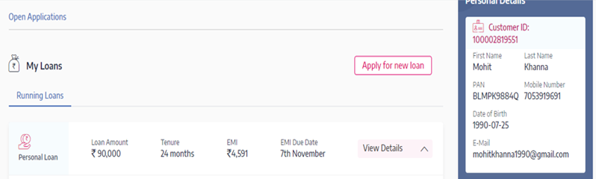

* On Selecting the loan customer should be able to See following details, with API fetch from Pennant
  + New API Required ( Total Outstanding and Next EMI )
  + New API Integration required RazorPay for Payment
  + New API fetch for Remaining loan amount (P+I)

|  |  |
| --- | --- |
| **Loan Details**   * Customer Unique ID * Loan Account Number * Interest Rate * EMI Cycle * RPS Download * Account Statement download * NOC download option as current scenario in case loan is closed along with SMS trigger ( PL & Individual BL: Non TDS case) * E-Agreement ( New) * Welcome Letter (New) * Interest certificate (New) | **Repayment Details**   * Total Loan Amount * Total Amount due   + Penal Amount * Loan Maturity Date * Remaining Loan Amount ( New) * Next Payment Due Date * Total Outstanding With option to pay using RazorPay API (New) * Next EMI Amount With option to pay using RazorPay API (New) |

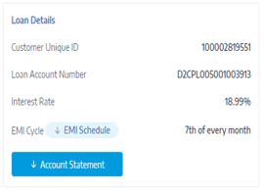 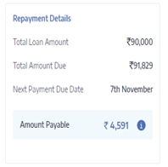

* NOC will be enable only when overdue charged are nil even when loans are closed.
* New Tab which will have payment summary details for selected loan. It should have following fields
  + Payment Date
  + Transaction Reference number
  + Transaction Type
  + Amount
  + Transaction Status

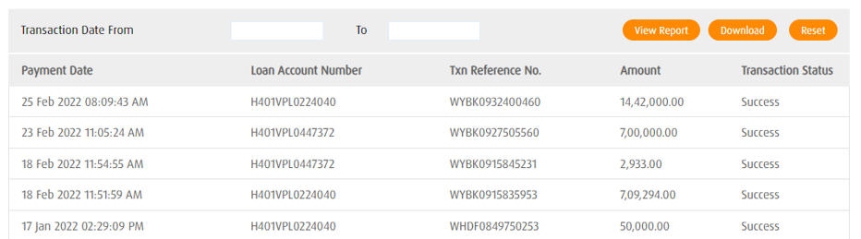

* New Tab which will enable customer to raise a query/issue which will be directly registered in CRM. Also there should be provision to see result of previously raised queries from CRM. Refer to Query Type in appendix for details.
  + In case customer has insurance related query, text field to choose insurance number

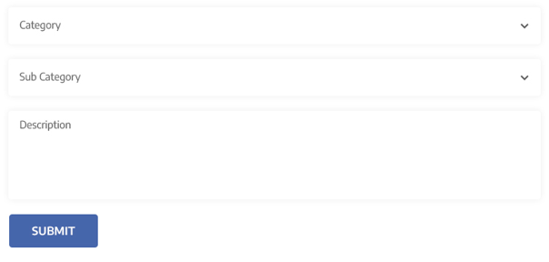

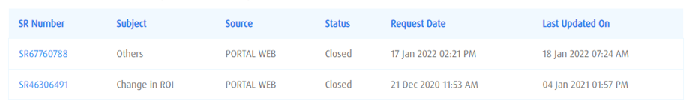

* For Cases where foreclosure request is made, After Retention Process (Offline) there should be process/Tab for enabling triggering FC payment which can be enabled of said case.
* Process/Option of enabling Charges/payment from backend post customer request. I.e LOD etc.
* For cases where documents are requested, Process should be available to upload scanned documents post payment of changes
* New Tab which will enable customer to change his current contact details (Mobile & e-mail) using OTP authentication to both his old and new contact details. These details should be automatically update in pennant.

**Appendix**

**Case Type and Sub Type ( We can re-look at this)**

